Why Silver Magnolias?

A horrible month had unfolded that rattled me. In fact, it had been a horrible few years. Multiple things had erupted in my life. Cancer had knocked on my door. What I thought was a trusted friend and partner had embezzled over a million dollars and I was trying to rebuild my business and me. And then, September third arrived and with it, the news that my nineteen-year-old son had died in an accident.
It was September of 1983.
At the end of the month, a women appeared at my front door. One of Frank’s friend’s moms was at my door with a plant. “We all loved it when Frank was over and I wanted you to have my favorite plant. It’s beautiful when blooming and I thought of your Frank as it bloomed this past week in our yard,” were her words.
Thanking her for thinking of us … of me, she transferred the small nursery pot to my hands. Hugged me and left.
I love plants and the garden and found a spot. Little did I know the plant was a tree—a silver magnolia that could thrive in our Northern California location. Little did I know that it would become the tree with the traveling roots.
There would be two more rented houses, being forced from our home for many years when the embezzlement hit. Each time, I dug up my silver magnolia plant and took it with me and replanted it remembering her words. When I moved to Colorado a few years later, it was left behind, now all of four feet. Hubby John was shutting down his business to join me. Arriving in Colorado, he walked in the door with the four-foot silver magnolia in our VW van. “I knew you would want this,” was all he said as he carried it into the house.
He was right. The traveling roots had once again uprooted and moved again.
Finding a spot in the small backyard of our townhome that I had negotiated to buy with the last of two of my art pieces when we moved, it settled in, re-rooted, and grew taller. When we built our new home seven years later, our now eight-foot-tall tree travelled to it. During the seven years, it had never bloomed. After all, Colorado wasn’t its ideal environment. I found the best protected spot in a corner where the library outer wall connected with the garage and replanted my old friend.
It seemed to like it, adding more height and filling in, tucked in its corner of the world. One weekend, my four-year old grandson Frankie was with us. He was out front with Papa John doing boy stuff in the front yard. I heard the screen door open and small feet rushing to find me. “Gramma … Gramma,” Frankie shouted. “Come … it’s a miracle … a MIRACLE!”
I was clueless to what he was referring to. He took my hand and pulled me toward the front door and down the two steps. Stopping, he pointed toward the tree. The miracle was five blooms … the first in over 15 years. Sitting on the porch step, Frankie positioned himself on my lap. We both marveled at the overnight miracle.
It was a miracle.
We lived there for 20 years before our needs changed with John’s health. The tree couldn’t go with us with the next move. Way too big, and it had found its spot. After the first miracle, each spring I would enjoy the blooms—usually white but sometimes pink and purple would appear. It had been a treasured friend for almost three decades.
Lifting me up at times. Generating calmness. Spreading a smile. A true friend … that’s what a silver magnolia is.
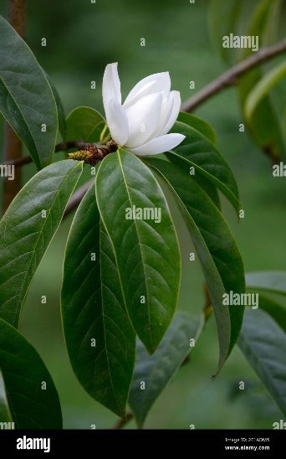
The stories and books that are written and published within the Silver Magnolia series will always have friendship at their core.

